A STUDY ON FINANCIAL PERFORMANCE OF ALLOYSYS EXTRUSION PVT LTD
ABSTRACT
The project titled “A study on financial performance” conducted in Alloysys Extrusion Pvt Ltd is to analyse the financial position of the Company. The objective of this project is to find out the efficiency of the Company using financial ratios like profitability ratios, turnover ratio & solvency ratio of the Company, to find out the liquidity position of the Company, to study the performance of Company through comparative analysis and to provide suitable suggest improving the financial performance of the Company.
The project is pertained to the Company’s data available for the past five years. The conclusions are drawn from the analysis done with the ratios, comparative, common size study. The study elucidates the financial position of the Company with respect to the past five years. It helps the Company to place itself among various other competitive companies.
The study through the analysis reveals the pros and cons of the Company’s financial status. It enables the reader to understand the various financial aspects of a Company through uncomplicated interpretation and findings for study purpose.
Financial performance can improve the financial strength of Company. The Company’s liquidity position has to increase and it will solve future problem. The Company is maintaining the reserves and surplus better so it can face financial stress in the future. To proper maintain of financial performance to achieve the Company goal.

TABLE OF CONTENTS
CHAPTER | PARTICULARS | PAGE NOS
I | INTRODUCTION
II | INDUSTRY PROFILE
 | COMPANY PROFILE
III | REVIEW OF LITERATURE
IV | RESEARCH METHODOLOGY
 | 4.1 RESEARCH DESIGN
 | 4.2 NEED FOR THE STUDY
 | 4.3 OBJECTIVES OF THE STUDY
 | 4.4 SCOPE OF THE STUDY
 | 4.5 LIMITATIONS OF THE STUDY
 | 4.6 TOOLS USED FOR ANALYSIS
V | DATA ANALYSIS AND INTERPRETATION
VI | FINDINGS
VII | SUGGESTIONS
VIII | CONCLUSION
 | REFERENCE
 | ANNEXURE

TABLE CONTENTS
CHAPTER | PARTICULARS | PAGE NOS
1 | Proprietary ratio
2 | Current ratio
3 | Cash position ratio
4 | Earning per share
5 | Divident payout ratio
6 | Debt-equity ratio
7 | Fixed asset ratio
8 | Fixed assets to networth ratio
9 | Debt to total capital ratio
10 | Debt to total assets ratio
11 | Comparative balance sheet for the year 2016-2017
12 | Comparative balance sheet for the year 2017-2018
13 | Comparative balance sheet for the year 2018-2019
14 | Comparative balance sheet for the year 2019-2020
15 | Common size balance sheet – 2016-2017
16 | Common size balance sheet – 2017-2018
17 | Common size balance sheet – 2018-2019
18 | Common size balance sheet – 2019-2020
19 | Trend percentage of total income
20 | Trend percentage of current asset
21 | Trend percentage current liabilities
22 | Trend percentage total debt
23 | Trend percentage total income

CHART CONTENTS
CHAPTER | PARTICULARS | PAGE NOS
1 | Proprietary ratio
2 | Current ratio
3 | Cash position ratio
4 | Earning per share
5 | Divident payout ratio
6 | Debt-equity ratio
7 | Fixed asset ratio
8 | Fixed assets to networth ratio
9 | Debt to total capital ratio
10 | Debt to total assets ratio
11 | Trend percentage of total income
12 | Trend percentage of current asset
13 | Trend percentage current liabilities
14 | Trend percentage total debt
15 | Trend percentage total income

CHAPTER 1
Financial Performance in broader sense refers to the degree to which financial objectives being or has been accomplished and is an important aspect of finance risk management. It is the process of measuring the results of a firm's policies and operations in monetary terms. It is used to measure firm's overall financial health over a given period of time and can also be used to compare similar firms across the same industry or to compare industries or sectors in aggregation.
Financial statements are primarily prepared for decision-making. They play a dominant role in setting the framework of managerial decision. The published financial statements of business may be of considerable interest to present the same to their respective potential shareholders, managers, moneylenders, banks, financial institutions, trade organization and many others.
Financial analysis is the process of identifying the financial strengths and weakness of firm by properly establishing relationship between the items of the balance sheet and profit and loss account. The purpose of financial analysis is to diagnose the information contained in the financial statements so as to judge the profitability and financial soundness of the firm. A financial analyst, analyses the financial statements with various tools of analysis before commenting upon the financial position of the enterprises

IMPORTANCE OF FINANCIAL STATEMENT ANALYSIS
The interest of various related groups is affected by the financial performance of a firm. The type of analysis varies according to the specific interest of the party Involved:
- Trade creditors: interested in the liquidity of the firm (appraisal of firm’s liquidity)
- Bond holders: interested in the cash-flow ability of the firm (appraisal of firm’s capital structure, the major sources and uses of funds, profitability over time, and projection of future profitability)
- Investors: interested in present and expected future earnings as well as stability of these earnings (appraisal of firm’s profitability and financial condition)
- Management: interested in internal control, better financial condition and better performance (appraisal of firm’s present financial condition, evaluation of opportunities in relation to this current position, return on investment provided by various assets of the company etc.)
OBJECTIVES OF FINANCIAL ANALYSIS
Financial statement analysis is very much helpful in assessing the financial position and profitability of a concern. The main objectives of analyzing the financial statements are as follows:
- The analysis would enable the present and the future earning capacity and the profitability of the concern.
- The operational efficiency of the concern as a whole as well as department wise can be assessed. Hence the management can easily locate the areas of efficiency and inefficiency.
- The solvency of the firm, both short-term and long-term, can be determined with the help of financial statement analysis which is beneficial to trade creditors and debenture holders.
- The comparative study in regard to one firm with another firm or one department with another department is possible by the analysis of financial statements.
- Analysis of past results in respects of earning and financial position of the enterprise is of great help in forecasting the future results. Hence it helps in preparing budgets.
- It facilitates the assessments of financial stability of the concern.
- The long-term liquidity position of funds can be assessed by the analysis of financial statements.
LIMITATIONS OF FINANCIAL ANALYSIS
- Owing to the fact that financial statements are compiled on the basis of historical costs, while there is a market decline in the value of the monetary unit and resultant rise in prices, the figures in the financial statement loses its functions as an index on current economic realities. Again the financial statements contain both items. So an analysis of financial statements cannot be taken as an indicator for future forecasting and planning.
- Analysis of financial statements is a tool which can be used profitably by an expert analyst but may lead to faulty conclusions if used by unskilled analyst. So the result cannot be taken as judgments or conclusions.
- Financial statements are interim reports and therefore cannot be final because the final gain or loss can be computed only at the termination of the business. Financial statement reflects the progress of the position of the business so analysis of these statements will not be a conclusive evidence of the performance of the business.
- Financial statements though expressed in exact monetary terms are not absolutely final and accurate and it depends upon the judgment of the management in respect of various accounting methods. If there is change in accounting methods, the analysis may have no comparable basis and the result will be biased.
- The reliability of analysis depends on the accuracy of the figures used in the financial statements. The analysis will be vitiated by manipulations in the income statement or balance sheet and accounting procedure adopted by the accountant for recording.
- The results for indications derived from analysis of financial statements may be differently interpreted by different users.
- The analysis of financial statement relating to a single year only will have limited use. Hence the analysis may be extended over a number of years so that results may be compared to arrive a meaningful conclusion.
- When different firms are adopting different accounting procedures, records, policies and different items under similar headings in the financial statements, the comparison will be more difficult. It will not provide reliable basis to access the performance, efficiency, profitability and financial condition of the firm as compared to industry as a whole.
- There are different tool of analysis available for the analyst. However, which tool is to be used in a particular situation depends on the skill, training, and expertise of the analyst and the result will vary accordingly
USEFULNESS OF FINANCIAL PERFORMANCE TO VARIOUS STAKEHOLDERS
The analysis of financial performance is used by most of the business communities. They include the following.
1. Trade Creditors The creditors provide goods / services on credit to the firm. They always face concern about recovery of their money. The creditors are always keen to know about the liquidity position of the firm. Thus, the financial performance parameters for them evolve around short term liquidity condition of the firm.
2. Suppliers of long term debt the suppliers of long term debt provide finance for the on-going / expansion projects of the firm. The long term debt providers will always focus upon the solvency condition and survival of the business. Their confidence in the firm is of utmost importance as they are providing finance for a longer period of time. Thus, for them the financial performance parameters evolve around the following:
i) Firm’s profitability over a period of time.
ii) Firm’s ability to generate cash - to be able to pay interest and
iii) Firm’s ability to generate cash – to be able to repay the principal and iv) The relationship between various sources of funds.
The long term creditors do consider the historical financial statements for the financial performance.
However, the financial institutions \ bank also depends a lot on the projected financial statements indicating performance of the firm. Normally, the projections are prepared on the basis of expected capacity expansion, projected level of production \ service and market trends for the price movements of the raw material as well as finished goods.
3. Investors are the persons who have invested their money in the equity share capital of the firm. They are the most concerned community as they have also taken risk of investments – expecting a better financial performance of the firm. The investors’ community always put more confidence in firm’s steady growth in earnings. They judge the performance of the company by analyzing firm’s present and future profitability, revenue stream and risk position.
4. Management for a firm is always keen on financial analysis. It is ultimately the responsibility of the management to look at the most effective utilization of the resources. Management always tries to match effective balance between the asset liability management, effective risk management and short-term and long-term solvency condition.

CHAPTER 2
1.2 INDSTRY PROFILE
Aluminium Industry in India is a highly concentrated industry with the top 5 companies constituting the majority of the country's production. With the growing demand of aluminium in India, the Indian aluminium industry is also growing at an enviable pace. In fact, the production of aluminium in India is currently outpacing the demand.
Though India's per capita consumption of aluminium stands too low (under 1 kg) comparing to the per capita consumptions of other countries like US & Europe (range from 25 to 30 kgs), Japan (15 kgs), Taiwan (10 kgs) and China (3 kgs), the demand is growing gradually. In India, the industries that require aluminium most include power (44%), consumer durables, transportation (10-12%), construction (17%) and packaging etc.
The Background
Though the existence of Aluminium was first established in the year 1808, it took almost 46 years to make its production commercially viable. The research work of several years resulted in extracting the aluminium from the ore. Aluminium is third most available element in the earth constituting almost 7.3% by mass. Currently it is also the second most used metal in the world after steel. Due to the consistent growth of Indian economy at a rate of 8%, the demand for metals, used for various sectors, is also on the higher side. As a result, the Indian aluminium industry is also growing consistently. In FY09, the aluminium industry in India saw a growth of about 9%.
The production of aluminium started in India in 1938 when the Aluminum Corporation of India's plant was commissioned. The plant which was set up with a financial and technical collaboration with Alcan, Canada had a capacity of producing 2,500 ton per annum. Hindustan Aluminum Corporation (Hindalco) was set up in UP in the year 1959; it had a capacity of producing 20,000 ton per annum. In 1965, a public sector enterprise Malco which had a capacity of 10,000 ton per annum was commissioned; by 1987, National Aluminium Company (NALCO) was commissioned to produce aluminium. It had a capacity of producing 0.218 million ton.
During the 1970s, the government started regulating and controlling the Indian aluminium industry. Restrictions in entry and price distribution controls were quite common in the Indian aluminium sector. Aluminium Control Order was implemented where the aluminium producers had to sell 50% of their products for electrical usages. However, in 1989, the order was removed as the government decontrolling was revoked. With de-licensing of industry in 1991, the liberal import of technologies and capital goods was started. The liberalization resulted in a growth rate of 12% of the industry, comparing to the growth rate of 6% during the 1980.
Aluminium Production in India
India is world's fifth largest aluminium producer with an aluminium production competence of around 2.7 million tones, accounting almost 5% of the total aluminium production in the world. India is also a huge reservoir of Bauxite with a Bauxite reserve of 3 billion tones.
The Production
India lies at the eighth position in the list of leading primary aluminium producers in the world. India saw a significant growth in aluminium production in the past five years. In 2006-07, the production target of aluminium in India laid by the Ministry of Mines, Government of India was 1,153 KT, which was augmented to 1,237 KT in the next year (2007-08). Due to the growing demand from the construction, electrical, automobiles and packaging industry, the production of aluminium also hiked up. In FY 09, the total aluminium production in India was around 1.35 tonnes.
The Consumption
After a stagnant consumption of primary aluminium in India from the end of 1990s to 2002 (when the consumptions were between 500 – 600 KT), it started rising sharply since 2002. The consumption reached at 1,080 KT in 2006. The consumption of aluminium in India is dominated by the industries like power, infrastructure, and transportation etc.
The Major Players
The Indian aluminium industry is dominated by four or five companies that constitute the majority of India's aluminium production. Following are the major players in the Indian aluminium industry:
- Hindustan Aluminium Company (HINDALCO)
- National Aluminium Company (NALCO)
- Bharat Aluminium Company (BALCO)
- MALCO
- INDAL
HINDALCO: Hindalco is the biggest player in the aluminium industry in India with around 39% of market share. An Aditya Birla Group flagship company, Hindalco has its aluminium plant at Renukoot in Uttar Pradesh. It has various aluminium products with a market share of 42% in primary aluminium, 20% in extrusions 63% in rolled products, 31% in wheels and 44% in foils.
Sterlite Industries: The aluminium business of Sterlite Industries Limited comprises of two Indian aluminium giants – BALCO and MALCO. While BALCO is a partially integrated, MALCO is a fully integrated producer of aluminium. Sterlite has got a market share of around 32%.
NALCO: It is also one of the leading aluminium producers in India. Government of India has a stake of 87.15% in this company. Its aluminium refinery is located at Damanjodi. It also has a smelter located at Angul, Orissa. Currently, NALCO is concentrating on a capex programme to increase its production from 345,000 tonnes to 460,000 tonnes. - See more at: http://business.mapsofindia.com/aluminium/#sthash.LWXX9FMj.dpuf

The most commercially mined aluminium ore is bauxite, as it has the highest content of the base metal. The primary aluminium production process consists of three stages. First is mining of bauxite, followed by refining of bauxite to alumina and finally smelting of alumina to aluminium. India has the fifth largest bauxite reserves with deposits of about 3 bn tonnes or 5% of world deposits. India's share in world aluminium capacity rests at about 3%. Production of 1 tonne of aluminium requires 2 tonnes of alumina while production of 1 tonne of alumina requires 2 to 3 tonnes of bauxite.
- The aluminium production process can be categorized into upstream and downstream activities. The upstream process involves mining and refining while the downstream process involves smelting and casting & fabricating. Downstream-fabricated products consist of rods, sheets, extrusions and foils.
- Power is amongst the largest cost component in manufacturing of aluminium, as the production involves electrolysis. Consequently, manufacturers are located near cheap and abundant sources of electricity such as hydroelectric power plants. Alternatively, they could set up captive power plants, which is the pattern in India. Indian manufacturers are the lowest cost producers of the base metal due to access to captive power, cheap labour and proximity to abundant supply of raw material, i.e., bauxite.
- The Indian aluminium sector is characterised by large integrated players like Hindalco and National Aluminium Company (Nalco). The other producers of primary aluminium include Bharat Aluminium (Balco), a subsidiary of Vedanta Resources.
- Aluminium offers a rare combination of valuable properties. It is three times lighter than Iron but is almost as strong as steel, extremely flexible and corrosion resistant due to thin surface layer of aluminum oxide. Aluminum has been continuously finding new applications due to rising price competence, superior weight to strength ratio, corrosion resistance, formability, dampness etc.
- On the industrial side, aluminium is heavily used in electrical power transmission, machinery and equipment, and construction. Housing, in particular, makes heavy use of the lightweight material as a substitute for steel and wood in doors, windows and siding. On the consumer side, aluminium is used in a variety of retail products, including cans, packaging, air conditioners, furniture and vehicles.

HOW TO RESEARCH THE ALUMINIUM SECTOR (KEY POINTS)
- Supply
- Supply of aluminum is in excess and any deficit can be imported at low rates of duty. Currently, the demand is stable while supply is in excess.
- Demand
- Demand for aluminium is estimated to grow at 6%-8% per annum in view of the low per capita consumption in India. Also, demand for the metal is expected to pick up as the scenario improves for user industries, like power, infrastructure and transportation.
- Barriers to entry
- Large economies of scale. Consequently, high capital costs.
- Bargaining power of suppliers
- Most domestic players operate integrated plants. Bargaining power is limited in case of power purchase, as Government is the only supplier. However, increasing usage of captive power plants (CPP) will help to rationalize power costs to a certain extent in the long-term.
- Bargaining power of customers
- Being a commodity, customers enjoy relatively high bargaining power, as prices are determined on demand and supply.
- Competition
- Competition is primarily on quality and price, as being a commodity, differentiation is difficult. However, the recent spate of consolidation has reduced the competitive pressure in the industry. Further, increasing value addition to aluminium products has helped some companies protect themselves from the high volatilities witnessed in this industry.

FINANCIAL YEAR '15 (why 2015?Write about 2021)
- The commodity markets, and in particular the aluminium industry, are going through a challenging phase at present because of the sharp slide in realizations.
- During the last quarter of FY15, heightened risk averseness led to dumping of commodities across the board. The resultant rise in US$, coupled with surging Chinese exports following slowing demand growth in China resulted in a sharp decline in LME, which dropped sharply by almost 10%. This was also accompanied with significant decline in regional premium, resulting in a large decline in all inclusive aluminium realisations putting pressure on margins.
- Aluminium prices on LME have declined quite sharply over the last few months due to confluence of many factors such as heightened risk averseness, European region uncertainty related to Greece, slowing demand growth from China and rising exports from it.
- The premiums across the regions have declined over 70%. This was primarily on account of large inventory de-stocking, which was the result of carry trade becoming less attractive, which in turn can be attributed to various factors such as change in LME warehousing rules, flattening of forward curve resulting into decline in contago, tightened regulatory environment that discouraged warehousing and impending spectre of Fed increasing interest rates resulting in higher financing costs.
- Due to above reasons, Realisations have declined sharply in recent months due to excess supplies. This scenario may continue for a while and hence over short term, realisations may remain under pressure.
- Global demand for aluminium has historically tended to outperform that for other metals. The weak price performance in some of the recent years has been more due to supply side developments than any issues with demand. In 2014, global aluminium consumption rose 5.5% YoY, the fastest pace in three years, despite the slowdown in Chinese consumption growth to around 8%.
- China accounted for 44% of global primary aluminium consumption in 2014, up from 23% in 2005. As the country continues to develop towards a more consumer-focused economy, aluminium consumption is expected to become more consumer-driven. Aluminium consumption in the USA has recovered well since the financial crisis, rising by over a third in the five years to 2014. However consumption still remains 20% below pre-crisis peak levels. European demand has struggled to grow in recent years, as it has been affected by the ongoing economic slowdown.
- Indian aluminium demand rose by 38% in the five years to 2014. India is currently the world's fifth-largest consumer of aluminium, behind China, the USA, Japan and Germany, and it is expected that the strong demand fundamentals have potential to elevate the country to the No. 3 position by 2016.

PROSPECTS (SHOULD BE FOR 2022)
- The Indian recovery is on the mend and the economy is expected to grow at over 7.5% in FY16 and FY17. This would result in aluminium demand growth on account of stronger consumption and investment. The government's thrust on power sector that went through a challenging phase bodes well for aluminium industry as power sector is a strong demand driver for aluminium consumption in India.
- The US demand is expected to remain strong growing at a CAGR of 4-5% over next few years, as the housing recovery gains traction, car sales continue to improve and aluminium demand benefits from new applications, particularly in the automotive sector. Western Europe is expected to grow moderately amidst economic uncertainty. The aluminium demand is expected to grow at around 2.5%
- In 2015, Chinese aluminium demand is expected to grow at around 6-7%, a substantial slowdown from the double-digit increase of the past decade. Demand growth will be strongest in consumer-related sectors.
- In short term, Chinese supply is expected to continue to impact Rest of the World demand-supply dynamics adversely. However in long term, overall the demand supply scenario for primary aluminium globally looks encouraging as demand continues to be robust with expectations of around 6% growth.
- On the positive side, the reduction in prices of crude derivatives in the recent months is expected to help on the cost front. In the recent quarters, coal availability in India is showing signs of improvement. With the expected growth in output of public sector coal mining companies and the likely operationalization of captive coal blocks, coal availability in the country may improve further, which will ease the cost-side pressures.

2.2 COMPANY PROFILE

Alloysys Extrusion [P] Ltd came into existence in 2005. The journey from manufacturing aluminium extrusion to becoming one of the best makers of Quality Aluminium Extrusions have been filled with accomplishments and accolades. Alloysys Extrusion aims to have a global presence as a leading global manufacturer of high quality Aluminium extruded products. The endeavors of the organization are focused towards achieving all-round excellence. The organization seeks to accomplish a fusion of traditional methods and innovative concepts to supply the best quality extruded product. Alloysys Extrusion manufactures wide variety Aluminium extrusions like extruded channel, extruded section or extruded profile that meet diversified usage.
Alloysys Extrusion has been maintaining its utmost standards of precision and quality and founded on the philosophy of ensuring uncompromising satisfaction to our customers. We have excellent time delivery of all the versatile extrusion products and these products are adding a new dimension to the modern building construction technology and to our business. Alloysys Extrusion [P] Ltd as the acknowledged market leaders have set up benchmarks for quality, timely delivery and client satisfaction. We have a unique combination of being flexible and an ability to react very quickly to changes in designs and specifications. This has ensured that our products and services to all our customers have been acclaimed internationally. From the beginning, we have always had a strong foundation of adaptability and experience. Always working very closely with customers, we have developed our products and services in tune with the market developments and requirements.
Meeting with customer's need and satisfaction is the true achievement
Alloysys Extrusion believes and follows this only statement at the time of manufacturing the products. This idea has helped Alloysys Extrusion to set a clear picture towards company's goal. Alloysys Extrusion is all set to have a wide range of all kind extrusions in near future. Alloysys Extrusion have well known in eastern part of the country.

ALLOYSYS EXTRUSION currently has automatic hydraulic presses with a production capacity of 3,000 MT per annum. The company offers the standard aluminium extrusions profiling and also is able to take care of specific designs and requirements.
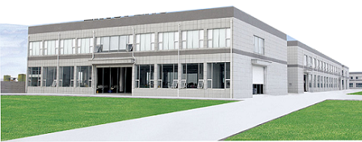

CAPABILITIES

- Automated Hydraulic Extrusion Presses
- Capacity: 3000 MT per annum
- Die Library: 1000
- profiles ranging from 10mm - 150 mm CCD
- Section weight up to 17 kg per piece
- Wall thicknesses minimum 0 .5mm - 20 mm
- Cut lengths up to 6-7m
- Standard alloy ranges

MISSION:
To become the most preferred aluminium extrusion company, focusing on manufacturing the high quality extruded products with excellent service consistently.
VISION:
We shall be producing high quality aluminium extrusions with our organizational expansion so that we shall always be able to meet the expectations of our all business associated people and specially our consumers.

PRODUCTS
1. Architectural

a) ALUMINIUM EXTRUDED DOOR PARTITION SERIES
- All
- Partitions
- Middle Section
- Top Bottom
- 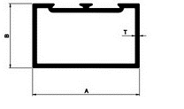
Single Partition
- 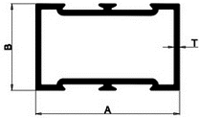
Double Partition
- 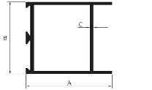
Door Top
- 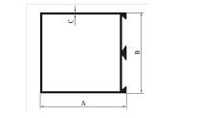
Door Middle Single
- 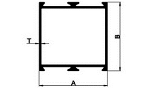
Door Middle Double
- 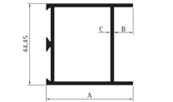
Door Bottom
- 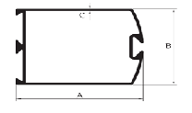
Door Vertical
- 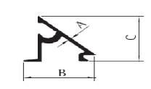
Glazing Clip
- 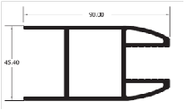

B) ALUMINIUM EXTRUDED CURTAIN WALL SERIES
- 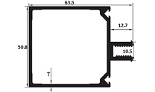
Curtain Wall Section 1423
- 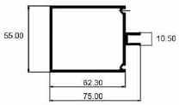
Curtain Wall Section 1426
- 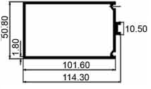
Curtain Wall Section 1431

C) ALUMINIUM EXTRUDED HOLLOW SECTION SERIES
- 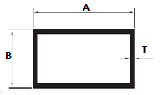
Rectangular Tube
- 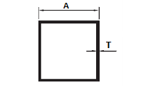
Square Tube

D) ALUMINIUM EXTRUDED OPENABLE WINDOW SERIES
- All
- 34 Series
- 40 Series
- Cleat Angle
- 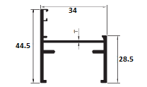
34 Series Outer Frame
- 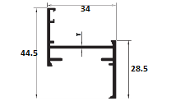
34 Series Shutter Frame
- 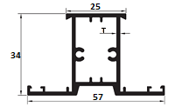
34 Series Mullian
- 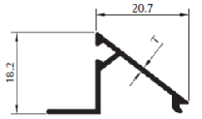
34 Series Clip
- 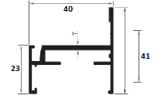
40 Series Outer Frame
- 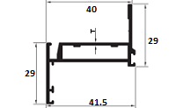
40 Series Shutter Frame
- 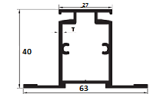
40 Series Mullian
- 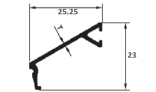
40 Series Clip
- 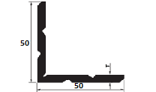
Cleat Angle

E) ALUMINIUM EXTRUDED TEE SERIES
- 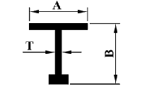
Bulb Tee

2. Industrial

A) ALUMINUM EXTRUDED ANGLE SECTION SERIES
- 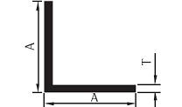
Equal Angle
- 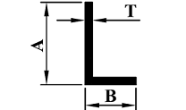
Unequal Angle

B) ALUMINUM EXTRUDED LADDER SECTION SERIES
- 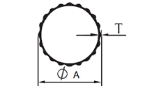
Fluted Tube
- 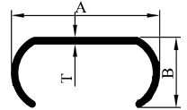
C Section
- 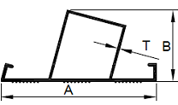
Stapazing
- 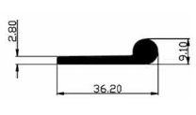
Hinge

C) ALUMINUM EXTRUDED WATER CHANNEL SECTIONS
- 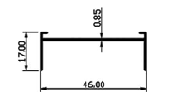
Water Channel Section 7506
- 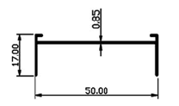
Water Channel Section 7511

D) ALUMINUM EXTRUDED ROUND TUBE
- 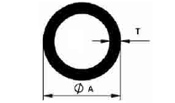
Round Tube

E) ALUMINUM EXTRUDED L SECTIONS
- 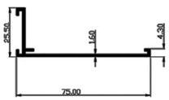
L Section

F) ALUMINUM EXTRUDED DOUBLE ROLLER SECTIONS
- 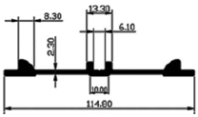
Double Roller Section

CUSTOM EXTRUSION

1. INDUSTRY SPECIALIZATION
Aluminium extrusion technology in modern industries continues to be a subject of discussion and evaluation concerning its application to the working environment. The demand for and application of aluminium extrusion in architecture and in the manufacture of auto mobiles, small machine components, structural component and especially aircraft, have increased tremendously, and competition in this industry is intense. The extrusion industry is now more than 100 old.
Industrial Uses: Aluminium is used extensively in almost countless application because of its high strength combined with low density. Also it is corrosion resistant to the atmosphere as a thin film of aluminium oxide forms over aluminium surfaces which protect it from further corrosion. Also, aluminium is non-toxic making it suitable for application involving contact with food products.
The most extensive and biggest use of aluminium is in packing. It used for packing in various forms such as cans, foils, tubes, and bottle tops. Second biggest use of extruded aluminium is in transportation. Aluminium extruded sections are widely used in most transport vehicles. It is particularly suited for aeroplanes. A modern aeroplane contains about 80% aluminium by weight; A Boeing 747 contains about 75 tons of aluminium.
Electrical transmission is another very big application area for aluminium. It has about 63% of electrical conductivity of copper but only half the density. That makes it a very attractive substitute for copper in electric cables and transmission lines. Particular for bare conductors of transmission lines, aluminium is the only choice.
Aluminium finds very big application in construction industry as forming Architectural channels or sections of window and door frames, cladding, and roofing. Aluminium is also used for painting other surfaces. Aluminium is also used extensively for making stylish and light weight furniture. It is particularly popular for folding and other type of furniture which is intended to be shifted and stored away frequently.

2. THE EXTRUSION PROCESS
Extrusion is a plastic deformation process in which a block of metal (billet) is forced to flow by comparison through the die opening of a smaller cross - sectional area than that of the original billet. Extrusion is an indirect - compression process. Indirect - compressive forces are developed by the reaction of the work piece (billet) with the container and die results in high values. The reaction of the billet with the container and die results in high compressive stresses that many breakdowns from the billet. Extrusion is the best method because the billet is subjected to compressive forces only. Extrusion can be cold or hot, depending on the alloy and the method used. In hot extrusion, the billet is preheated to facilitate plastic deformation. Conventional Direct Extrusion: The most important and common method used on aluminium extrusion is the direct process. In this process, the principle of direct extrusion, the billet is placed in the container and pushed through the die by the ram pressure. Direct extrusion finds application in the manufacture of aluminium solid rods,aluminium bars, hollow tubes, and hollow and solid sections according to the design and shape of the die. In the same direction as ram travel. During this process, the billet slides relative to the walls of the container. The resulting frictional force increases the ram pressure considerably. During the direct extrusion, the load or pressure - displacement curve most commonly. Traditionally, the process has been described as having three distinct regions:
- The billet is upset, and pressure rises rapidly to its peak value.
- The pressure decreases, and what is termed "steady state" extrusion proceeds.

3. EXTRUSION IDEA TO OBJECT
"Meeting with customer's need and satisfaction is the true achievement", we also believe and follow this only statement at the time of manufacturing our extruded products
The process initiates with the necessity or demand of an Extruded profile. Once the necessity arrives, it demands specific die for that extrusion product which results in the making of specific die for the product After getting the die, finally the production phase of that particular extruded product takes place in plant under the process.

QUALITY MANAGEMENT
1. QUALITY CONTROL AND COMPLIANCES
At Alloysys Extrusion, we do not compromise on quality, we walk an extra mile to sustain the quality. What we have done is that we have standardized the process of quality compliance checks. The quality compliance tests are not carried out randomly but it is a well defined process carried out continuously at every stage of production. An error does not become a mistake until you refuse to correct it. With this principle the Alloysys Extrusion has in place a complete traceability system to trace down the root cause of deviation, should they happen to occur. We are fully geared with the requisite technical expertise and quality control mechanism, which leads us to successfully meet even the bulk orders of the clients. Additionally, our streamlined administration, regular follow-ups with the clients and quick order dispatch has enabled us to win the faith and trust of the customers.
Alloysys extrusions is awarded ISO 9001:2008 Certification by international agency norsk akkreditering of norway for its quality management standards.

2. TECHNICAL SPECIFICATION
Aluminium is a soft, durable, lightweight, ductile and malleable metal with appearance ranging from silvery to dull gray, depending on the surface roughness. Aluminium is nonmagnetic and does not easily ignite. A fresh film of aluminium film serves as a good reflector (approximately 92%) of visible light and an excellent reflector (as much as 98%) of medium and far infrared radiation. The yield strength of pure aluminium is 7-11 MPa, while aluminium alloys have yield strengths ranging from 200 MPa to 600 MPa. Aluminium has about one-third the density and stiffness of steel. It is easily machined, cast, drawn and extruded. Corrosion resistance can be excellent due to a thin surface layer of aluminium oxide that forms when the metal is exposed to air, effectively preventing further oxidation. The strongest aluminium alloys are less corrosion resistant due to galvanic reactions with alloyed copper. This corrosion resistance is also often greatly reduced when many aqueous salts are present, particularly in the presence of dissimilar metals. Aluminium is one of the few metals that retain full silvery reflectance in finely powdered form, making it an important component of silver-colored paints.

WHAT OUR PRODUCTS OFFER WITH RESPECT TO THE TECHNICAL SPECIFICATION
- Corrosion-Resistant
- High Strength-to-Weight Ratio
- Ease of Fabrication
- Ease of Fastening and Assembly
- Versatility in Joining
- Durable, Resilient and Strong etc.

3. USES
Aluminium is almost always alloyed, which markedly improves its mechanical properties, especially when tempered. For example, the common aluminium foils and beverage cans are alloys of 92% to 99% aluminium. The main alloying agents are copper, zinc, magnesium, manganese, and silicon (e.g., duralumin) and the levels of these other metals are in the range of a few percent by weight. With completely new metal products, the design choices are often governed by the choice of manufacturing technology. Extrusions are particularly important in this regard, owing to the ease with which aluminium alloys, particularly the Al-Mg-Si series, can be extruded to form complex extruded profiles.

CHAPTER 3
REVIEW OF LITERATURE
The study of (Shin & Soenen, 1998) consistent with later study on the same objective that done by (Deloof, 2003) by using sample of 1009 large Belgian non-financial firms for the period of 1992-1996. However, (Deloof, 2003) used trade credit policy and inventory policy are measured by number of days accounts receivable, accounts payable and inventories, and the cash conversion cycle as a comprehensive measure of working capital management. He founds a significant negative relation between gross operating income and the number of days accounts receivable, inventories and accounts payable. Thus, he suggests that managers can create value for their shareholders by reducing the number of days accounts receivable and inventories to a reasonable minimum. He also suggests that less profitable firms wait longer to pay their bills.
In other study, (Lyroudi & Lazaridis, 2007) use food industry Greek to examined the cash conversion cycle () as a liquidity indicator of the firms and tries to determine its relationship with the current and the quick ratios, with its component variables, and investigates the implications of the terms of profitability, indebtness and firm size. The results of their study indicate that there is a significant positive relationship between the cash conversion cycle and the traditional liquidity measures of current and quick ratios. The cash conversion cycle also positively related to the return on assets and the net profit margin but had no linear relationship with the leverage ratios. Conversely, the current and quick ratios had negative relationship with the debt to equity ratio, and a positive one with the times interest earned ratio. Finally, there is no difference between the liquidity ratios of large and small firms.
Working capital policy refers to the firm's policies regarding 1) target levels for each category of current operating assets and liabilities, and 2) how current assets will be financed. Generally good working capital policy (i.e. under conditions of certainty) is considered to be one in which holdings of cash, securities, inventories, fixed assets, and accounts payables are minimized. The level of accounts receivables should be used as a means of stimulating sales and other income. Previous literature on working capital management has found a negative association, overall, between level of working capital and operating performance as measured by operating returns and operating margins (Peterson and Rajan, 1997). Under conditions of certainty (i.e. sales, costs, lead times, payment periods, and so on, are known), firms have little reason to hold more working capital than a minimum level. Larger amounts would increase the level of operating assets, increase the need for external funding, resulting in lower return on assets and a lower return on equity, without any increase in profit.
However the picture changes when uncertainty (i.e. uncertain growth) is introduced (Brigham and Houston, 2007). Larger amounts of cash, securities, accounts receivables, marketable securities, inventories, and fixed assets will be needed to support increased sales Required levels will be based on expected sales levels and expected order lead times. Additional holdings may be needed to enable the firm to deal with departures from the expected values. Further, firms will also attempt to increase their accounts payable balances as a means of financing increased levels of current operating assets. Firms which are in high growth stages will face the challenge of maintaining the necessary level of operating assets to support subsequent growth, while at the same time attempting to maintain adequate performance indicators.
This study focuses on understanding how IPO companies manage their working capital and other balance sheet items to support subsequent growth. This study supports the existing literature on working capital and contributes to the existing literature by examining a sample of firms (i.e. recent IPO firms) which have a wider range of growth levels than non-IPO firms. Our study examines the impact of working capital management on the operating performance and growth of new public companies. The study also examines these relationships under three categories of growth (i.e. negative growth, moderate growth, and high growth). The study also examines other selected firm characteristics in light of working capital management: firm operating and financial risk, amount of debt, firm size, and industry.
An underlying theme of this study is that high growth certainly does not ensure high operating performance. Consistent with prior research (Peterson and Rajan, 1997) this study provides further evidence that good working capital management is positively associated with better operating performance. Higher levels of accounts receivable are associated with higher operating performance, in all three of the growth rate categories. The study also finds that maintaining control over levels of cash, securities, inventory, fixed assets, and accounts payables is associated with higher operating performance. We find that firms which are experiencing very high growth will hold higher levels of cash, securities, inventory, fixed assets, and accounts payable to support the high growth. The study suggests that these firms are sacrificing operating performance (accepting lower operating returns) to support the high growth. This, in turn, increases financial and operating risk for these firms. Perhaps IPO firms should stay more focused on their operating performance, while maintaining more moderate growth levels.

- In the article of financial analysis Dr.Kamm, Department of Finance. GSB

Financial Analysis is designed for finance majors in order to improve their skills at analyzing companies and to advance their knowledge of finance theory and application. The overall financial analysis includes: bond valuation, financial statement analysis, financial ratios, financial forecasting, beta and the CAPM, the weighted average cost of capital, the Gordon Growth model, discounted cash flow analysis and multiples. Students are expected to integrate skills of finance, economics, and accounting in the course. The course is quantitative and analytical in nature; we made use of the trading center throughout most of the term. Students calculate and interpret financial data, build spreadsheet models, and make general conclusions about the financial health of a Company and its intrinsic value.

2. IN THE ARTICLE OF MEASURING FINANCIAL PERFORMANCE (A Critical Key to Managing Risk)
Dr. Laurence M. Crane.
FINANCIAL STATEMENTS
Financial statements help assess the financial well-being of the overall operation. Information about the financial results of each enterprise and physical asset is important for management decisions, but by themselves are inadequate for some decisions because they do not describe the whole business. An understanding of the overall financial situation requires three key financial documents: the balance sheet, the income statement and the cash flow statement.

FINANCIAL PERFORMANCE MEASURES
The recommended measures for financial analysis are grouped into five broad categories: liquidity, solvency, profitability, repayment capacity and financial efficiency.

Financial measures are intended to help operations analyze their activities from a financial standpoint and provide useful information needed to make good management decisions. By themselves, the financial measures discussed don’t provide answers—they need to be reviewed in relation to each other and to other non-operation activities. It is not possible to control or predict all of the factors that influence the final outcome of any operational decision. Nor is it possible to have available all of the information that would be ideal. But decision making can be improved through using available information and through effective financial planning and analysis.

3. ADVANCED FINANCIAL STATEMENTS ANALYSIS
By David Harper

The System
Financial statements paint a picture of the transactions that flow through a business. Each transaction or exchange - for example, the sale of a product or the use of a rented a building block - contributes to the whole picture.
Let's approach the financial statements by following a flow of cash-based transactions. In the illustration below, we have numbered four major steps:

1. Shareholders and lenders supply capital (cash) to the Company.
2. The capital suppliers have claims on the Company. The balance sheet is an updated record of the capital invested in the business. On the right-hand side of the balance sheet, lenders hold liabilities and shareholder’s hold equity. The equity claim is "residual", which means shareholders own whatever assets remain after deducting liabilities. The capital is used to buy assets, which are itemized on the left-hand side of the balance sheet. The assets are current, such as inventory, or long-term, such as a manufacturing plant.
3. The assets are deployed to create cash flow in the current year (cash inflows are shown in green, outflows shown in red). Selling equity and issuing debt start the process by raising cash. The Company then "puts the cash to use" by purchasing assets in order to create (build or buy) inventory. The inventory helps the Company make sales (generate revenue), and most of the revenue is used to pay operating costs, which include salaries.
4. After paying costs (and taxes), the Company can do three things with its cash profits. One, it can (or probably must) pay interest on its debt. Two, it can pay dividends to shareholders at its discretion. And three, it can retain or re-invest the remaining profits. The retained profits increase the shareholders' equity account (retained earnings). In theory, these reinvested funds are held for the shareholders' benefit and reflected in a higher share price.

4. Financial Statements why it’s important for all business? By: john irronPosted: Jun 15, 2016

Financial statements are a formal record of the financial activities of a business, person, or other thing. Financial statements like a written statement which quantitatively describes the financial strength of a Company. This includes an income statement and a balance sheet, and regularly also includes a cash flow statement. Financial statements are regularly compiled on a quarterly and yearly basis.
Financial statements are important futures for each and every business. For a business venture, all the appropriate financial information, offered in a structured way and in a form simple to understand, are called the financial statements.
The purpose of financial statements is to give information regarding the financial situation, performance and changes in financial situation of a venture that is helpful to a wide range of users in making financial decisions. Financial statements should be comprehensible, appropriate, reliable and comparable. Reported property, liabilities and equity are directly connected to an organization's financial situation. Reported income and operating cost are directly connected to an organization's financial performance.
5. THE PROFESSION OF PROFESSIONAL “Financial Analysis” By: Abdullah Mohammad Khan WAHID Post on: October 4, 2016.
A financial analysis is responsible for a wide range of functions such as account processing payable and receivable operations, taking into account the transfer of assets and the closing of the books as soon as possible. Properly fulfill these functions is essential for a Company, on the basis of precise handling operations and accurate financial statements. These activities are clearly on the basis of any successful career in financial analysis. However, the organizer has exceptional skills in analyzing appropriate funding for success.
This article was calculated to facilitate analysis financial support for a breadth and depth of the largest financial analysis.
Traditionally – the main objective of the accounting department has been processing transactions, customer billing, payments to suppliers, etc. These are routine activities that are invisible, but vital. Most employees of the Company, but it is always necessary for the success of an organization.
However, the role of accounting staff that has been changed companies facing increasing competition from organizations around the world. Now, managing a business needs advice and transaction flow smoothly? Accordingly, the financial analyst is not only to fill the role of traditional transaction processing, but also to continue to review Company operations, evaluating investments, relationship problems and recommendations for management, and respond to requests by the management team of Special Investigations. All these new tasks can be considered as financial analysis, because require the application of review procedures for operational activities and financial investment in a Company.

6. Financial Statement Analysis By: Rashid Javed
Posted: Jan 19, 2018
All financial statements are essentially historically historical documents. They tell what has happened during a particular period of time. However most users of financial statements are concerned about what will happen in the future. Stockholders are concerned with future earnings and dividends. Creditors are concerned with the Company's future ability to repay its debts. Managers are concerned with the Company's ability to finance future expansion. Despite the fact that financial statements are historical documents, they can still provide valuable information bearing on all of these concerns.

Financial statement analysis involves careful selection of data from financial statements for the primary purpose of forecasting the financial health of the Company. This is accomplished by examining trends in key financial data, comparing financial data across companies, and analyzing key financial ratios.

CHAPTER 4
RESEARCH METHODOLOGY
Research methodology is a way to systematically solve the research problem. It may be understood as a science of study how research is done scientifically. In this study the various steps that are generally adopted by the researcher in studying his research problem along with the logic behind them.
4.1 Research design
The proposed study is of DESCIRPTIVE IN NATURE. Research design is needed because it facilitates the smooth sailing of the various research operations, thereby making research as efficient as possible. A research design for a particular problem usually involves the consideration of the following factors.
SOURCE OF INFORMATION
Basically there are two sources of information. The researcher has collected secondary data for his study.
PRIMARY DATA
Information was collected through this source comprises of discussions with the personnel of Alloysys Extrusion Pvt Ltd
SECONDARY DATA
The data was collected from sources like magazine, journals, Company reports and industrial magazines (annual reports). The financial data has been analysed for 5 years namely 2015-16 to 2019-2020
RESEARCH TYPE
Research type is the basic frame work which provides guidelines for the research process. The research design chosen for the study by the researcher was Analytical in nature. The researcher has to use facts of information already available. The researcher has to analyze facts to make critical evaluation of the material.
The choice of the research type depends on the depth and extent of data recording, the cost and benefits of research, the urgency of work, the time availability of competing its research and the blue print of the research project.
4.1 NEED FOR THE STUDY
Financial analysis is a powerful mechanism which helps in ascertaining the strengths and weakness in the operation and financial position of an enterprise. Financial analysis is the starting point for making plans, before using any sophistical forecasting and planning procedures. This study helps to understand financial position of the company. This study suggests possible solution to overcome working capital problem. The financial statements need to evaluate a company's profitability, liquidity, and solvency. The most common methods used for financial statement analysis are trend analysis, common‐size statements, and ratio analysis. These methods include calculations and comparisons of the results to historical company data, competitors, or industry averages to determine the relative strength and performance of the company being analyzed.
4.3 OBJECTIVES OF THE STUDY
Primary Objectives
The main aim of the study is to ascertain financial performance of Alloysys Extrusion Pvt Ltd for the past five years.
Secondary Objectives
- To find out the efficiency of using financial ratios like profitability ratios, turnover ratio & solvency ratio.
- To find out the liquidity position.
- To study the performance of through comparative analysis.
- To provide suitable suggest to improve the financial performance.
4.4 SCOPE OF THE STUDY
The project is pertained to the company’s data available for the past five years namely 2015-16 to2019-2020. The conclusions are drawn from the analysis done with the ratios, comparative, common size study. The study elucidates the financial position of the company with respect to the past five years. It helps the company to place itself among various other competitive companies.
The study through the analysis reveals the pros and cons of the company’s financial status. It enables the reader to understand the various financial aspects of a company through uncomplicated interpretation and findings for study purpose.
4.5 LIMITATIONS OF THE STUDY
The limitations of the study are as follows
1. The study is covered only to the past financial performance of Alloysys Extrusion Pvt Ltd
2. Some of the data has not given by the company due to maintenance of financial secrecy.
3. The period of the study is restricted to 5 years
4. So the study cannot be covered to all the areas. The financial data cannot be estimated accurately for the future period due to the financial crisis.
4.6 TOOLS USED FOR ANALYSIS
The following are major tools used in analysis and interpretation.
- Ratio analysis
- Common size balance sheet statement.
- Comparative balance sheet statement.
- Trend percentage analysis.
RATIO ANALYSIS
A ratio is a mathematical relationship between two items expressed in a quantitative form. Ratio can be defined as “Relationship expressed kin quantitative terms between figures which have cause and effect relationship which are connected with each other in some manner or the other. Ratio analysis involves the process of computing determining and presenting the relationship of items or groups of items of financial statements.
CURRENT RATIO
The ratio of current assets to current liabilities is called current ratio. In order to measure the short-term liquidity or solvency of a concern, comparison of current assets and current liabilities is inevitable. Current ratio indicates the ability of a concern to meet its current obligations as and when they are due for payment.
Current ratio = Current assets / Current liabilities
LIQUID RATIO
A measure of Company’s liquidity and ability to meet its obligations. Quick ratio, often referred to as acid-test ratio, is obtained by subtracting inventories from current assets and then dividing by current liabilities.
Liquid ratio = Liquid assets / current liabilities
WORKING CAPITAL TURNOVER RATIO
A measure comparing the depletion of working capital to the generation of sales over a given period. This provides some useful information as to how effectively a Company is using its working capital to generate sales.
Working capital turnover ratio = Net sales / Working Capital
PROFITABILITY RATIO
Profit making is the main objective of business. Aim of every business concern is to earn maximum profits in absolute term and also in relative terms i.e. profit is to be maximum in term of risk undertaken.
Profitability Ratio =Profit after tax / Sales
CASH POSITION RATIO
This ratio also known as absolute liquidity ratio or super quick ratio. It’s calculated when liquidity is highly restricted in terms of cash and cash equivalents.
Cash position ratio= cash and Company balances + marketable securities/ current liabilities.
OPERATING RATIO
Operating ratio represent the different between the cost of goods sold and sales. Operating ratio measures the amount of expenditure incurred in production, sales and distribution of output. It indicates operational efficiency of the concern.
OPERATING RATO= cost of goods sold + operating expenses / net sales *100
DEBTORS TURNOVER RATIO
It represents how quickly the debtors are converted into cash. This ratio is used to measure the firm’s liquidity position. This ratio establishes the relationship between receivables and credit sales.
Debtors turnover ratio = Net sales / Average debtors.
PROPRIETARY RATIO
This ratio is also termed as capital ratio or net worth to total asset ratio. This is one of the variant of dept equity ratio. This shows the relationship between shareholders funds and total assets
Proprietary ratio = Net worth / Total Assets
GROSS PROFIT RATIO
Gross profit ratio establishes the relationship between gross profit and net sales. It also reveals the amount of gross profit for each rupee of sale. This ratio is calculated by dividing the gross profit by Net sales. It is usually indicated as a percentage.
Gross Profit Ratio = Gross Profit / Net sales * 100
NET PROFIT RATIO
Net profit ratio is also termed as sales margin ratio or profit margin ratio or net profit to sales ratio. This ratio reveals the firm’s overall efficiency in operating the business. Net profit ratio is used to measure the relationship between net profit (either before or after taxes) and sales.
Net Profit Ratio = Net Profit / Net Sales * 100

COMPARETIVE BALANCE SHEET:
The comparative balance sheet analysis is the study of the trend of the same items, group of items and computed items in two or more balance sheet of the same business enterprise on different dates. The changes in periodic balance sheet items reflect the conduct of a business. The changes can be observed by comparison of the conduct of a business the changes can be observed by comparison of the balance sheet at the beginning at the end of period and these changes can help in forming an opinion about the progress of an enterprise.

Procedure of Comparative Balance Sheet:
- The Comparative balance sheet has two columns for the data of original balance sheet.
- Third column is used to show increases in figures.
- The Fourth column is use to give percentages of increase or decrease.
Uses of comparative balance sheet:
- comparative statement helps to comparing the figures with those of the previous year’s event, it is possible to determine where expenses increased or decreased
- Comparative balance sheet helps to how to plan the following year’s event.
COMMON SIZE BALANCE SHEET:
A balance sheet in which the items are expressed as percentages of total assets or total liabilities. A common-size statement is most useful when one attempts to compare a Company to similar companies of different size or when one is comparing year-to-year variations in capital structure in the same Company. This type of financial statement can be used to allow for easy analysis between companies or between time periods of a Company.

TREND PERCENTAGE ANALYSIS
The next important tools of analysis are trend percentage which plays significant role in analyzing the financial stature of the enterprise through base years’ performance ratio computation. This not only reveals the trend movement of the financial performance of the enterprise but also highlights the strengths and weaknesses of the enterprise This trend ratio is being computed for every component for many numbers of years which not only facilitates comparison but also guides the firm to understand the trend path of the firm.
The following ratio is being used to compute the trend percentage.
Current year
= -------------- X 100
Base year
CHAPTER V
5.1 RATIO ANALYSIS
5.1.1 PROPRIETARY RATIO
Proprietary Ratio shows the relationship between shareholders’ funds to total assets of the concern. The shareholders’ funds are equity share capital, preference share capital, undistributed profits, reserves and surpluses.
Shareholders’ Funds
Proprietary Ratio = --------------------------
Total Assets

TABLE: 5.1.1 PROPRIETARY RATIO
Year | Shareholder fund | Total Asset | Ratio (Times)
2016 | 49032.66 | 721526.32 | 0.067957
2017 | 57947.70 | 964432.08 | 0.060085
2018 | 65949.20 | 1053413.74 | 0.062605
2019 | 64986.04 | 1223736.20 | 0.053105
2020 | 83951.20 | 1335519.24 | 0.062860

SIGNIFICANCE
It shows that proprietary ratio was high in the year 2016 with 0.06 and low in the year 2019 with 0.05. Thus, it can be said that the Company is maintaining the long term solvency. The current year (2020) proprietary ratio is found to be 0.06 it is in a increasing position.
The Proprietory ratio which shows the relationship between the shareholder’s funds to total tangible assets. The ratio is has more or less been constant.
CHART: 5.1.1 PROPRIETARY RATIO
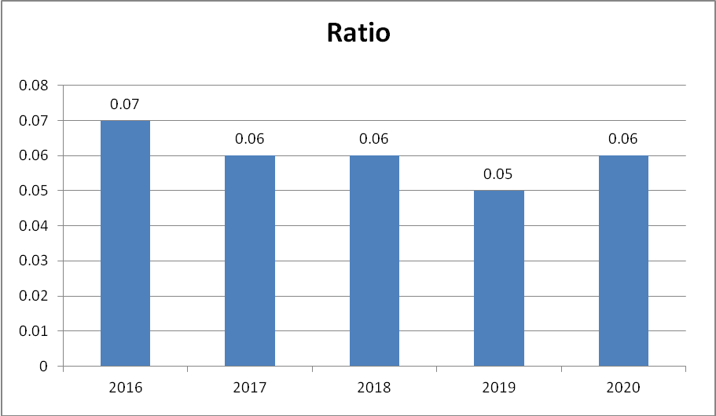
5.1.2CURRENT RATIO
Current ratio is an index of the concern’s financial stability. If a higher current ratio is an indication of in adequate employment of funds, a poor current ratio is a danger signal to the management.
Current Assets
Current Ratio = ----------------------
Current Liability

TABLE: 5.1.2 CURRENT RATIO
Year | Current Asset | Current Liability | Current Ratio
2016 | 484234.54 | 83362.30 | 5.81
2017 | 646907.00 | 110697.57 | 5.84
2018 | 728098.00 | 80336.70 | 9.06
2019 | 879593.60 | 105248.39 | 8.36
2020 | 964742.06 | 80915.09 | 11.92

SIGNIFICANCE
It shows that current ratio was high in the year 2020 with 11.92and low in the year 2016 with 5.81. The current year (2020) current ratio is found to be the highest (11.92) due to the decrease in the liabilities.
From the above table and chart the current ratio of the Company is strong. However a higher level of investment is locked up in current assets. If this is reduced, profitability can be increased further.

CHART: 5.1.2CURRENT RATIO
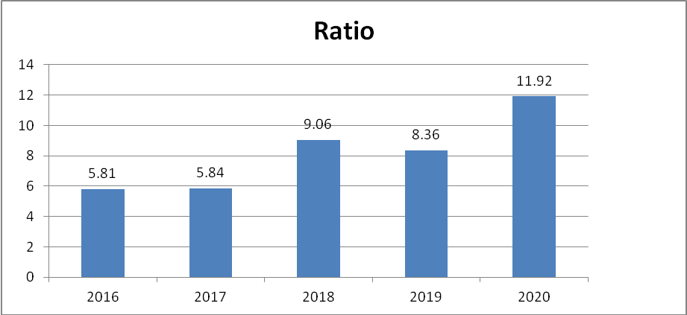

TABLE: 5.1.3 CASH POSITION RATIO
Year | Cash-Company | Current liabilities | Ratio (Times)
2016 | 67,466.34 | 83362.30 | 0.81
2017 | 104,403.80 | 110697.57 | 0.94
2018 | 96,183.85 | 80336.70 | 1.20
2019 | 122,874.15 | 105248.39 | 1.17
2020 | 97,163.17 | 80915.09 | 1.20
SOURCE: SECONDARY DATA
SIGNIFICANCE
From the table, it is inferred that the cash position ratio is high in the years 2018 and 2020 with 1.20 and low in the year 2016 with 0.81. The current year (2020) cash position ratio has increased to 1.20 when compared to the previous year 2019 with 1.17.
CHART: 5.1.3 CASH POSITION RATIO
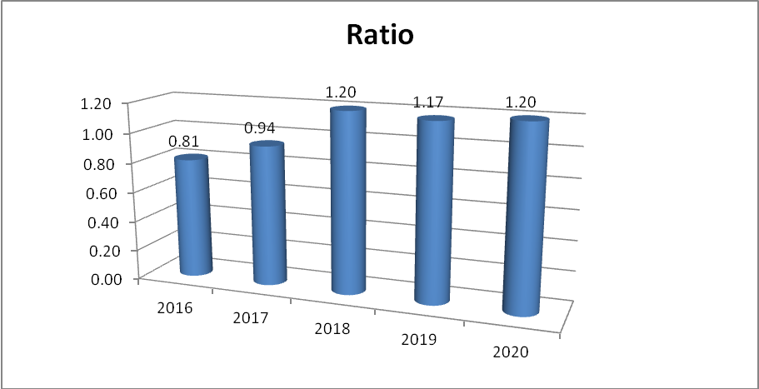

5.1.4 EARNING PER SHARE

Earning per share is a small variation of return on equity capital. It provides a view of the comparative earnings when it compares with that of similar other companies. Thus, the earnings per share are a good measure of profitability.
Net Profit After Preference Dividend
Earning Per Share = -------------------------------------------------
No. of Equity Shares

TABLE 5.1.7EARNING PER SHARE
Years | Net Profit After Preference Dividend | No. of equity shares | Rs
2016 | 6,729.46 | 631.47 | 10.656
2017 | 9,121.57 | 634.88 | 14.367
2018 | 9,166.39 | 634.88 | 14.437
2019 | 7,370.69 | 635.00 | 11.607
2020 | 11,713.34 | 671.04 | 17.415
SOURCE:SECONDARY DATA
SIGNIFICANCE
The earning per share shows was found to be high in the year 2020 with 17.41. The EPS has constantly been increasing except in the year 2019.
CHART:5.1.4-EARNING PER SHARE
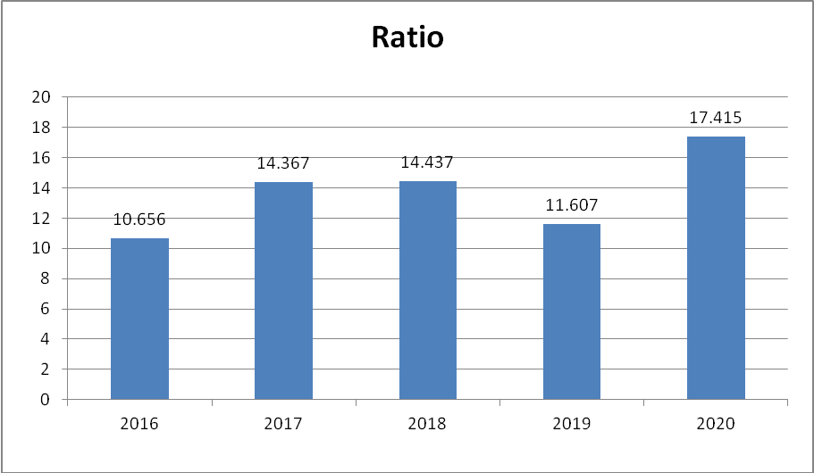

TABLE :5.1.5 DIVIDEND PAYOUT RATIO:
Divident Payout Ratio = Total Divident / Total Income

Year | Total Dividend | Total Income | Ratio’s
2016 | 1,357.66 | 6,729.46 | 0.20
2017 | 1,841.15 | 9,121.57 | 0.20
2018 | 1,904.65 | 9,166.39 | 0.21
2019 | 1,905.00 | 7,370.69 | 0.26
2020 | 2,348.66 | 11,713.34 | 0.20

Significance:
From the above table it is found that the dividend payout ratio is found to be high in the year 2019 with 26%. All other years the company has maintained a constant dividend payout ratio of almost 20% .

CHART:5.1.5 Dividend Payout Ratio:

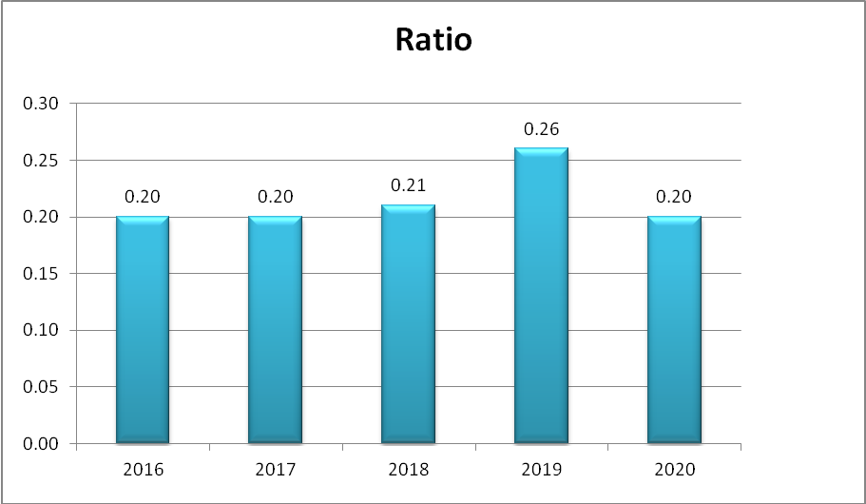

5.1.6 DEBT-EQUITY RATIO:
This ratio helps to ascertain the soundness of the long term financial position of the Company. It indicates the proportion between total long term debt and the shareholders funds. This also indicates the extent to which the firm depends upon outsiders for its existence.

FORMULA:-
Total long term debt
Debt-equity Ratio = ------------------------------------
Shareholders funds

TABLE 5.1.7: CHECK
Year | Total Long Term Debt | Shareholders Fund | Debt-Equity Ratio
2016 | 51727.41 | 631.47 | 81.91586
2017 | 53731.68 | 634.88 | 84.63281
2018 | 103011.60 | 634.88 | 162.2537
2019 | 119568.96 | 635.00 | 188.2976
2020 | 127005.57 | 671.04 | 189.2668

CHART 5.1.7:
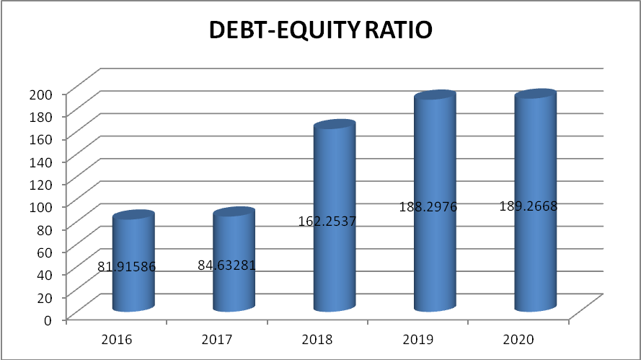
INFERENCE:
The debt-equity ratio is another leverage ratio that compares a Company's total liabilities to its total shareholders' equity. In the debt ratio, a lower the percentage means that a Company is using less leverage and has a stronger equity position. In the year 2020 the debt equity ratio is higher which means that the Company is having a higher leverage

5.1.8 FIXED ASSET RATIO:
This ratio establishes the relationship between fixed assets and long term funds. The objective of calculating this ratio is to ascertain the proportion of long term funds invested in fixed assets. The ratio is calculated as given below

FORMULA:-
Fixed asset
Fixed asset ratio = ------------------------------------
Long term Funds

TABLE 5.1.8:

Year | FIXED ASSET | LONG TERM FUND | FIXED ASSET RATIO
2016 | 3139.22 | 51727.41 | 6.068775
2017 | 3574.41 | 53731.68 | 6.652332
2018 | 4117.73 | 103011.60 | 3.997346
2019 | 4431.95 | 119568.96 | 3.706606
2020 | 5133.87 | 127005.57 | 4.04224

CHART5.1.8:
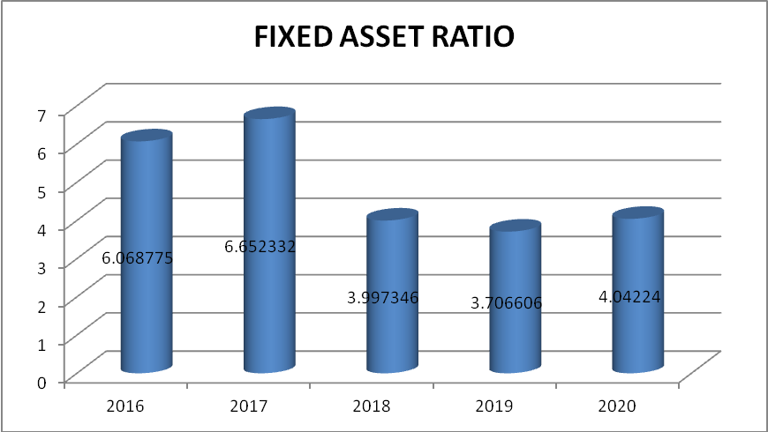
INFERENCE:
From the above chart it is inferred that the Company has invested same amount in both long term fund and the fixed asset. Even though the current year (2020) fixed assets are in the increasing rate that the ratios are equal to 0.002. This means that the Company’s fixed asset position is satisfactory. The company has decreased the level of borrowings in funding fixed assets.

5.1.9 FIXED ASSETS TO NETWORTH RATIO:
This ratio is relationship between fixed assets and share capital fund. This ratio is also called fixed assets to net worth ratio. Following is its formula:
= Fixed Assets / Share capital fund
TABLE 5.1.9
YEAR | FIXED ASSETS | SHARE CAPITAL FUND | FIXED ASSET TO SHARE CAPITAL FUND RATIO
2016 | 3139.22 | 631.47 | 4.97128921
2017 | 3574.41 | 634.88 | 5.63005607
2018 | 4117.73 | 634.88 | 6.48583984
2019 | 4431.95 | 635.00 | 6.97944882
2020 | 5133.87 | 671.04 | 7.65061695

CHARR 5.1.9:
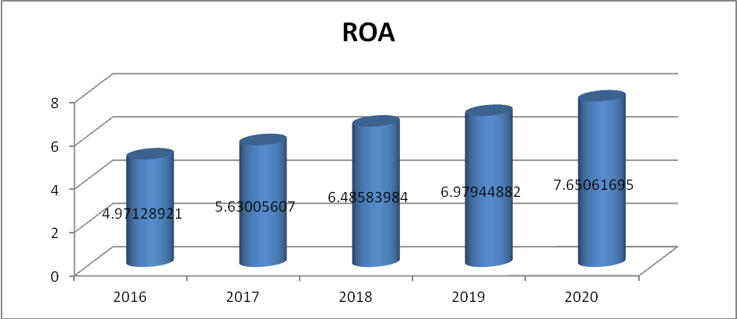
INFERENCE:
Fixed assets to net worth ratio 0.75 or higher is usually undesirable, as it indicates that the firm is vulnerable to unexpected events and changes in the business climate.
This ratio indicates the extent to which the owners' cash is frozen in the form of fixed assets, such as property, plant, and equipment, and the extent to which funds are available for the company's operations (i.e. for working capital). The current year fixed asset to net worth ratio is 7.65 which indicates that the firm is not vulnerable to unexpected events and changes in the business climate.

5.1.10DEBT TO TOTAL CAPITAL RATIO:
A measurement of a company's financial leverage, calculated as the company's debt divided by its total capital. Debt includes all short-term and long-term obligations. Total capital includes the company's debt and shareholders' equity, which includes common stock, preferred stock, minority interest and net debt.
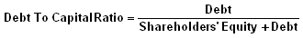
TABLE 5.1.10:
YEAR | DEBT | SHAREHOLDER’S EQUITY+DEBT | DEBT TO CAPITAL RATIO
2016 | 51727.41 | 52358.88 | 0.987939582
2017 | 53731.68 | 54366.56 | 0.988322233
2018 | 103011.60 | 103646.48 | 0.993874563
2019 | 119568.96 | 120223.96 | 0.994717312
2020 | 127005.57 | 127676.61 | 0.994744221

CHART5.1.10:
DEBT TO TOTAL CAPITAL RATIO
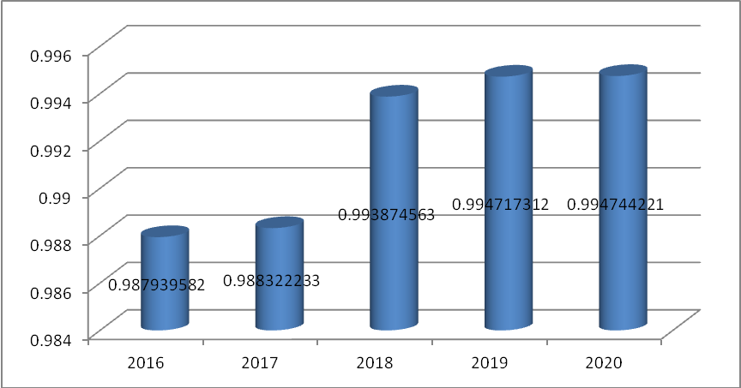
INFERENCE:
The debt-to-capital ratio is a refinement of the debt-to-assets ratio. It measures how much of the capital employed (i.e. the resources on which the company pays a cost) is debt. Higher debt included in the capital employed means higher risk of insolvency. The current year (2020) and the previous year (2019) ratio is high with 0.99%. It is almost at the ideal ratio of 1:1.

5.1.11 Debt to total assets ratio:
The debt to total assets ratio calculates the percent of assets provided by creditors. It is calculated by dividing total debt by total assets. Total debt is the same as total liabilities. Total debt to total assets is a leverage ratio that defines the total amount of debt relative to assets.
FORMULA:

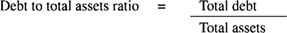

TABLE 5.1.11:
YEAR | TOTAL DEBT | TOTAL ASSETS | DEBT TO TOTAL ASSET RATIO
2016 | 51727.41 | 721526.32 | 7.169164667
2017 | 53731.68 | 964432.08 | 5.571328569
2018 | 103011.60 | 1053413.74 | 9.778835807
2019 | 119568.96 | 1223736.20 | 9.770811716
2020 | 127005.57 | 1335519.24 | 9.509827054

CHARR 5.1.11:
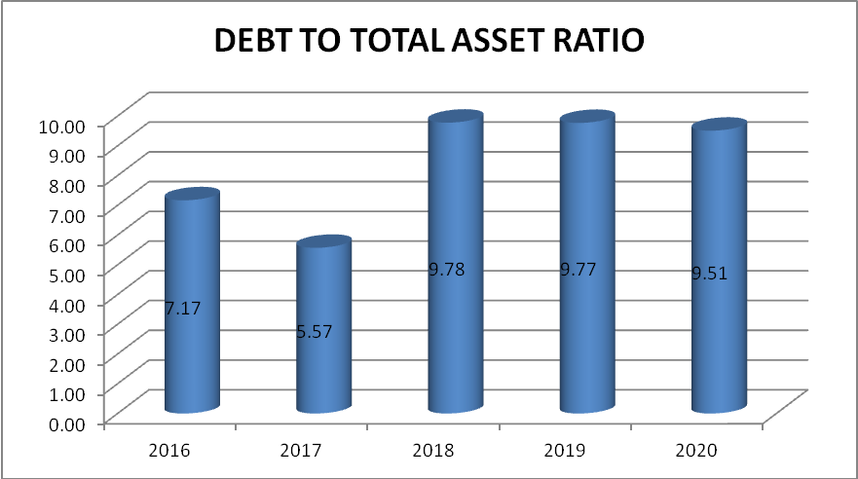

INFERENCE:
This enables comparisons of leverage to be made across different companies. The higher the ratio, the higher the degree of leverage, and consequently, financial risk. This is a broad ratio that includes long-term and short-term debt (borrowings maturing within one year), as well as all assets – tangible and intangible. The debt to total asset ratio is higher for the last 3 years this shows that the Company has a higher degree of leverage.

5.2 COMPARATIVE BALANCESHEET
5.2.1 COMPARATIVE BALANCESHEET FOR THE YEAR 2016-2017
PARTICULARS | 2016 | 2017 | Inc\ Dec | Inc\ Dec %
Fixed Asset: Gross block- Depreciation | 3139.22 | 3574.41 | 435.19 | 13.86
Capital work-in-progress | 234.26 | 263.44 | 29.18 | 12.46
Investments | 189501.27 | 275953.96 | 86452.69 | 45.62
Other assets | 44417.03 | 37733.27 | (6683.76) | (15.05)
Current assets
Cash & Balances | 51534.62 | 55546.17 | 4011.55 | 7.78
Balance in Company | 15931.72 | 48857.63 | 32925.91 | 206.67
Advances | 416768.20 | 542503.20 | 125735.00 | 30.17
TOTAL ASSETS | 721526.32 | 964432.08 | 242905.76 | 33.67
Current Liabilities
Other liabilities & provisions | 83362.30 | 110697.57 | 27335.27 | 32.79
Equity share capital | 631.47 | 634.88 | 3.41 | 0.54
Reserves & surplus | 48401.19 | 57312.82 | 8911.63 | 18.41
Debts
Deposits | 537403.94 | 742073.13 | 204669.19 | 38.08
Borrowings | 51727.41 | 53713.68 | 1986.27 | 3.84
TOTAL LIABILITIES | 721526.31 | 964432.08 | 242905.77 | 33.67

5.2 COMPARATIVE BALANCESHEET
5.2.2 COMPARATIVE BALANCESHEET FOR THE YEAR 2017-2018
PARTICULARS | 2017 | 2018 | Inc\ Dec | Inc\ Dec %
Fixed Asset: Gross block- Depreciation | 3574.41 | 4,117.73 | 543.32 | 15.20
Capital work-in-progress | 263.44 | 295.18 | 31.74 | 12.05
Investments | 275953.96 | 285790.07 | 9836.11 | 3.56
Other assets | 37733.27 | 35112.76 | (2620.51) | (6.94)
Current assets
Cash & Balances | 55546.17 | 61290.87 | 5744.70 | 10.34
Balance in Company | 48857.63 | 34892.98 | (13964.65) | (28.58)
Advances | 542503.20 | 631914.15 | 89410.95 | 16.48
TOTAL ASSETS | 964432.08 | 1053413.74 | 88981.66 | 9.23
Current Liabilities
Other liabilities & provisions | 110697.57 | 80336.70 | (30360.87) | (27.43)
Equity share capital | 634.88 | 634.88 | 0.00 | 0.00
Reserves & surplus | 57312.82 | 65314.32 | 8001.50 | 13.96
Debts
Deposits | 742073.13 | 804116.23 | 62043.10 | 8.36
Borrowings | 53713.68 | 103011.60 | 49297.92 | 91.78
TOTAL LIABILITIES | 964432.08 | 1053413.73 | 88981.65 | 9.23

5.2 COMPARATIVE BALANCESHEET
5.2.3 COMPARATIVE BALANCESHEET FOR THE YEAR 2018-2019
PARTICULARS | 2018 | 2019 | Inc\ Dec | Inc\ Dec %
Fixed Asset: Gross block- Depreciation | 4117.73 | 4431.95 | 314.22 | 7.63
Capital work-in-progress | 295.18 | 332.23 | 37.05 | 12.55
Investments | 285790.07 | 295600.57 | 9810.50 | 3.43
Other assets | 35112.76 | 43777.85 | 8665.09 | 24.68
Current assets
Cash & Balances | 61290.87 | 94395.50 | 33104.63 | 54.01
Balance in Company | 34892.98 | 28478.65 | (6414.33) | (18.38)
Advances | 631914.15 | 756719.45 | 124805.30 | 19.75
TOTAL ASSETS | 1053413.74 | 1223736.20 | 170322.46 | 16.17
Current Liabilities
Other liabilities & provisions | 80336.70 | 105248.39 | 24911.69 | 31.01
Equity share capital | 634.88 | 635.00 | 0.12 | 0.02
Reserves & surplus | 65314.32 | 64351.04 | (963.28) | (1.47)
Debts
Deposits | 804116.23 | 933932.81 | 129816.58 | 16.14
Borrowings | 103011.60 | 119568.96 | 16557.36 | 16.07
TOTAL LIABILITIES | 1053413.73 | 1223736.20 | 170322.47 | 16.17
5.2 COMPARATIVE BALANCESHEET
5.2.4 COMPARATIVE BALANCESHEET FOR THE YEAR 2019-2020
PARTICULARS | 2019 | 2020 | Inc\ Dec | Inc\ Dec %
Fixed Asset: Gross block- Depreciation | 4431.95 | 5133.87 | 701.92 | 15.84
Capital work-in-progress | 332.23 | 332.68 | 0.45 | 0.14
Investments | 295600.57 | 312197.61 | 16597.04 | 5.61
Other assets | 43777.85 | 53.113.02 | 9335.17 | 21.32
Current assets
Cash & Balances | 94395.50 | 54075.94 | (40319.56) | (42.71)
Balance in Company | 28478.65 | 43087.23 | 14608.58 | 51.30
Advances | 756719.45 | 867578.89 | 110859.44 | 14.65
TOTAL ASSETS | 1223736.20 | 1335519.24 | 111783.04 | 9.13
Current Liabilities
Other liabilities & provisions | 105248.39 | 80915.09 | (24333.30) | (23.12)
Equity share capital | 635.00 | 671.04 | 36.04 | 5.68
Reserves & surplus | 64351.04 | 83280.16 | 18929.12 | 29.42
Debts
Deposits | 933932.81 | 1043647.36 | 109714.55 | 11.75
Borrowings | 119568.96 | 127005.57 | 7436.61 | 6.22
TOTAL LIABILITIES | 1223736.20 | 1335519.22 | 111783.02 | 9.13

5.3 COMMONSIZE BALANCESHEET
TABLE 5.3.1 SHOWING COMMONSIZE BALANCE SHEET – 2016-2017(Rs in crs)
PARTICULARS | 2016 | PERCENTAGE | 2017 | PERCENTAGE
Fixed Asset: Gross block- Depreciation | 3139.22 | 0.44 | 3574.41 | 0.37
Capital work-in-progress | 234.26 | 0.03 | 263.44 | 0.03
Investments | 189501.27 | 26.26 | 275953.96 | 28.61
Other assets | 44417.03 | 6.16 | 37733.27 | 3.91
Current assets
Cash & Balances | 51534.62 | 7.14 | 55546.17 | 5.76
Balance in Company | 15931.72 | 2.21 | 48857.63 | 5.07
Advances | 416768.20 | 57.76 | 542503.20 | 56.25
TOTAL ASSETS | 721526.32 | 100 | 964432.08 | 100
Current Liabilities
Other liabilities & provisions | 83362.30 | 11.55 | 110697.57 | 11.48
Equity share capital | 631.47 | 0.09 | 634.88 | 0.07
Reserves & surplus | 48401.19 | 6.71 | 57312.82 | 5.94
Debts
Deposits | 537403.94 | 74.48 | 742073.13 | 76.94
Borrowings | 51727.41 | 7.17 | 53713.68 | 5.57
TOTAL LIABILITIES | 721526.31 | 100 | 964432.08 | 100
TABLE 5.3.2 SHOWING COMMONSIZE BALANCE SHEET – 2017-2018(Rs in crs)
PARTICULARS | 2017 | PERCENTAGE | 2018 | PERCENTAGE
Fixed Asset: Gross block- Depreciation | 3574.41 | 0.39 | 4,117.73 | 0.39
Capital work-in-progress | 263.44 | 0.03 | 295.18 | 0.03
Investments | 275953.96 | 27.13 | 285790.07 | 27.13
Other assets | 37733.27 | 3.33 | 35112.76 | 3.33
Current assets
Cash & Balances | 55546.17 | 5.82 | 61290.87 | 5.82
Balance in Company | 48857.63 | 3.31 | 34892.98 | 3.31
Advances | 542503.20 | 59.99 | 631914.15 | 59.99
TOTAL ASSETS | 964432.08 | 100.00 | 1053413.74 | 100.00
Current Liabilities
Other liabilities & provisions | 110697.57 | 7.63 | 80336.70 | 7.63
Equity share capital | 634.88 | 0.06 | 634.88 | 0.06
Reserves & surplus | 57312.82 | 6.20 | 65314.32 | 6.20
Debts
Deposits | 742073.13 | 76.33 | 804116.23 | 76.33
Borrowings | 53713.68 | 9.78 | 103011.60 | 9.78
TOTAL LIABILITIES | 964432.08 | 100.00 | 1053413.73 | 100.00

TABLE 5.3.3 SHOWING COMMONSIZE BALANCE SHEET – 2018-2019(Rs in crs)
PARTICULARS | 2018 | PERCENTAGE | 2019 | PERCENTAGE
Fixed Asset: Gross block- Depreciation | 4117.73 | 0.39 | 4431.95 | 0.36
Capital work-in-progress | 295.18 | 0.03 | 332.23 | 0.03
Investments | 285790.07 | 27.13 | 295600.57 | 24.16
Other assets | 35112.76 | 3.33 | 43777.85 | 3.58
Current assets
Cash & Balances | 61290.87 | 5.82 | 94395.50 | 7.71
Balance in Company | 34892.98 | 3.31 | 28478.65 | 2.33
Advances | 631914.15 | 59.99 | 756719.45 | 61.84
TOTAL ASSETS | 1053413.74 | 100.00 | 1223736.20 | 100.00
Current Liabilities
Other liabilities & provisions | 80336.70 | 7.63 | 105248.39 | 8.60
Equity share capital | 634.88 | 0.06 | 635.00 | 0.05
Reserves & surplus | 65314.32 | 6.20 | 64351.04 | 5.26
Debts
Deposits | 804116.23 | 76.33 | 933932.81 | 76.32
Borrowings | 103011.60 | 9.78 | 119568.96 | 9.77
TOTAL LIABILITIES | 1053413.73 | 100.00 | 1223736.20 | 100.00

TABLE 5.3.4 SHOWING COMMONSIZE BALANCE SHEET – 2019-2020(Rs in crs)
PARTICULARS | 2019 | PERCENTAGE | 2020 | PERCENTAGE
Fixed Asset: Gross block- Depreciation | 4431.95 | 0.36 | 5133.87 | 0.38
Capital work-in-progress | 332.23 | 0.03 | 332.68 | 0.02
Investments | 295600.57 | 24.16 | 312197.61 | 23.38
Other assets | 43777.85 | 3.58 | 53113.02 | 3.98
Current assets
Cash & Balances | 94395.50 | 7.71 | 54075.94 | 4.05
Balance in Company | 28478.65 | 2.33 | 43087.23 | 3.23
Advances | 756719.45 | 61.84 | 867578.89 | 64.96
TOTAL ASSETS | 1223736.20 | 100.00 | 1335519.24 | 100.00
Current Liabilities
Other liabilities & provisions | 105248.39 | 8.60 | 80915.09 | 6.06
Equity share capital | 635.00 | 0.05 | 671.04 | 0.05
Reserves & surplus | 64351.04 | 5.26 | 83280.16 | 6.24
Debts
Deposits | 933932.81 | 76.32 | 1043647.36 | 78.15
Borrowings | 119568.96 | 9.77 | 127005.57 | 9.51
TOTAL LIABILITIES | 1223736.20 | 100.00 | 1335519.22 | 100.00

5.4 TREND ANALYSIS
TABLE NO: 5.4.1
TABLE SHOWING TREND PERCENTAGE OF TOTAL INCOME
Year | TOTAL INCOME  (Rs in crs ) | TREND %
2016 | 6,729.46 | 100.00
2017 | 9,121.57 | 73.78
2018 | 9,166.39 | 73.41
2019 | 7,370.69 | 91.30
2020 | 11,713.34 | 57.45
Source: secondary data
CHART NO: 5.4.1.
CHART SHOWING TREND PERCENTAGE OF TOTAL INCOME
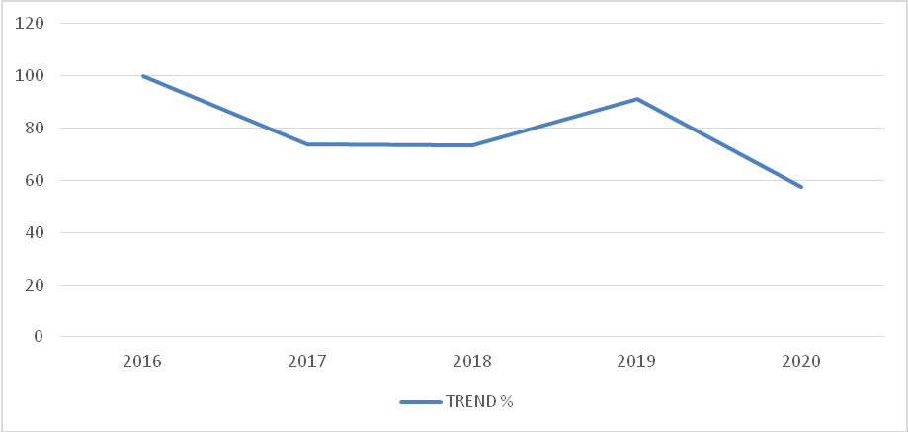
INFERENCE:
From the above trend analysis showing, it is inferred as base year 2016. The trend analysis for net income is lowest in the year 2020 with 57.45.
TABLE NO: 5.4.2.
TABLE SHOWING TREND PERCENTAGE OF CURRENT ASSET
Year | CURRENT ASSET  (Rs in crs ) | TREND %
2016 | 484234.54 | 100.00
2017 | 646907.00 | 74.85
2018 | 728098.00 | 66.51
2019 | 879593.60 | 55.05
2020 | 964742.06 | 50.19

CHART NO: 5.4.2
CHART SHOWING TREND PERCENTAGE OF CURRENT ASSET

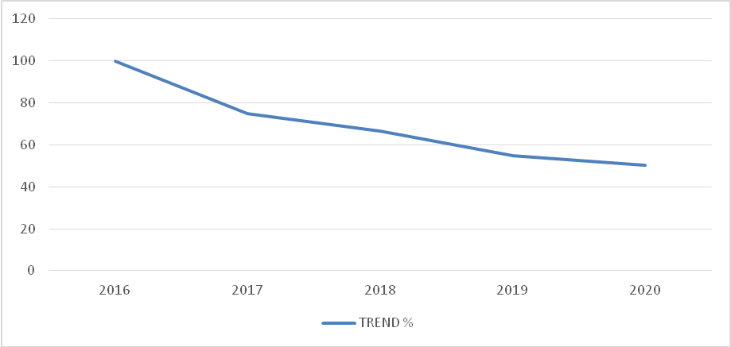
INFERENCE:
From the above trend analysis showing, it is inferred as base year 2016. Current asset has been decreased during the year 2020, 2019 and 2018. The current year 2020 trend percentage for current asset is 50.19.
TREND ANALYSIS
CURRENT LIABILITIES
TABLE 5.4.3
YEAR | CURRENT LIABILITY- y | x | xy | X² | Y = a + b x  (IN CRORES)
2016 | 83362.3 | -2 | -166725 | 4 | 94180.73
2017 | 110698 | -1 | -110698 | 1 | 93146.37
2018 | 80336.7 | 0 | 0 | 0 | 92112.01
2019 | 105248 | 1 | 105248.4 | 1 | 91077.65
2020 | 80915.1 | 2 | 161830.2 | 4 | 90043.29
 | ∑Y=460560.1 | ∑X= 0 | ∑XY=-10343.6 | ∑X²=10

Y = a + bX Where a = ∑Y ; b = ∑XY
n ∑X²

CURRENT LIABILITIES
FIGURE 5.4.3
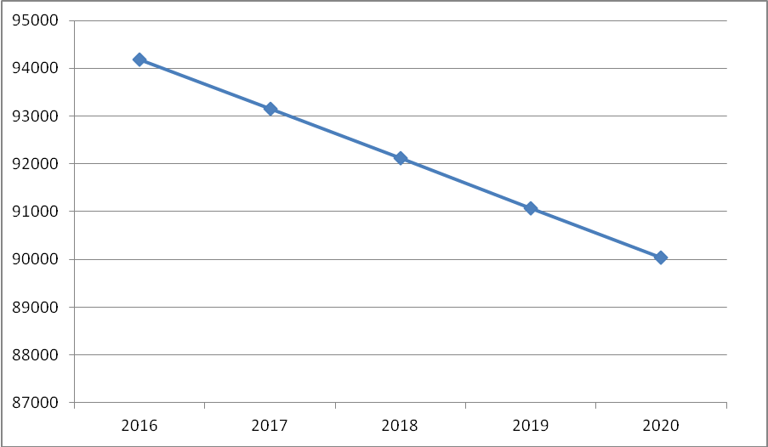

TOTAL DEBT
TABLE 5.4.4
YEAR | TOTAL DEBT | X | XY | X² | Y = a + b x  (IN CRORES)
2016 | 51727.41 | -2 | -103455 | 4 | 47730.32
2017 | 53731.68 | -1 | -53731.7 | 1 | 69369.68
2018 | 103011.60 | 0 | 0 | 0 | 91009.04
2019 | 119568.96 | 1 | 119569 | 1 | 112648.4
2020 | 127005.57 | 2 | 254011.1 | 4 | 134287.8
 | = 455045.2 | ∑X= 0 | ∑XY= 216393.6 | ∑X²=10

Y = a + bX Where a = ∑Y ; b = ∑XY
n ∑X²

TOTAL DEBT
FIGURE 5.4.4

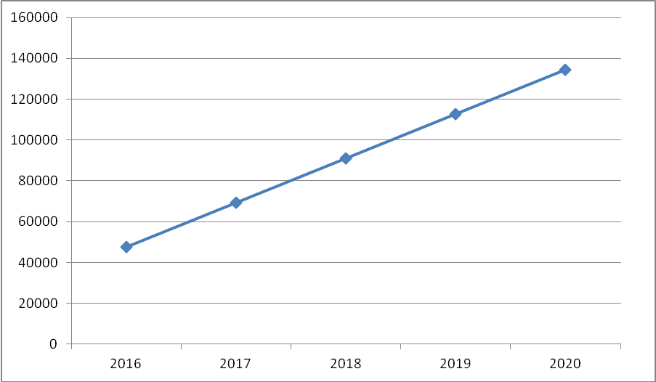

5.4.6 TOTAL INCOME
TABLE 5.4.6
YEARS | Total Income | X | XY | X² | Y = a + b x  (IN CRORES)
2016 | 6729.46 | -2 | -13458.9 | 4 | 7176.914
2017 | 9121.57 | -1 | -9121.57 | 1 | 7998.602
2018 | 9166.39 | 0 | 0 | 0 | 8820.29
2019 | 7370.69 | 1 | 7370.69 | 1 | 9641.978
2020 | 11713.34 | 2 | 23426.68 | 4 | 10463.67
 | ∑Y= 44101.45 | ∑X= -0 | ∑XY=8216.88 | ∑X²=10

Y = a + bX Where a = ∑Y ; b = ∑XY
n ∑X²

TOTAL INCOME
FIGURE 5.4.5
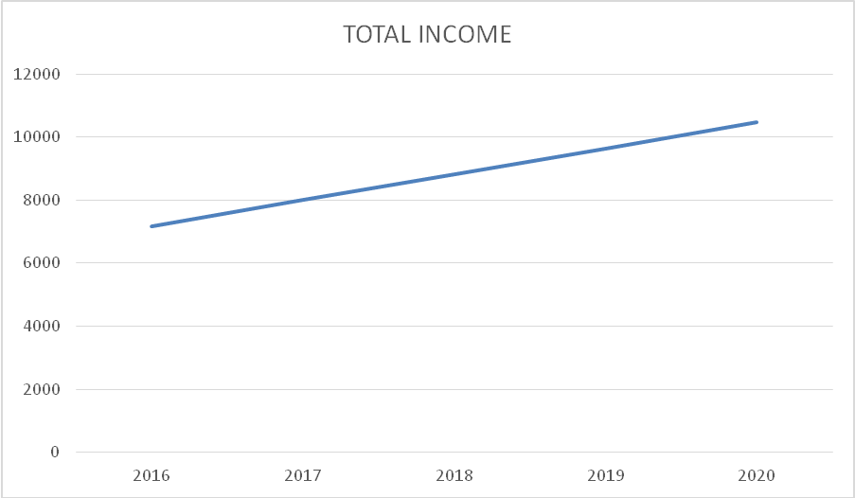

CHAPTER 6
FINDINGS
  - The current year (2020) proprietary ratio is found to be 0.06286 it is in a increasing position.
  - The current year (2020) current ratio is found to be the highest (11.92) due to the decrease in the liabilities.
  - The current year (2020) cash position ratio has increased to 1.20 when compared to the previous year 2019 with 1.17.
  - The current year (2020) earnings per share ratio is found to be increasing with 174.15 when compared to the previous year with 116.07. This is due to the increase in the net profit
  - The current year 2020 dividend payout ratio is found to be decreasing with 0.20 when compared to the previous year.
  - In the year 2020 the debt equity ratio is higher which means that the Company is having a higher leverage the current year (2020) fixed assets are in the increasing rate that the ratios are equal to 0.002. This means that the Company’s fixed asset position is satisfactory
  - The current year fixed asset to net worth ratio is 7.65 which indicate that the firm is not vulnerable to unexpected events and changes in the business climate.
  - The current year (2020) and the previous year (2019) ratio is high with 0.99%. This shows that the Company’s debts are very high and involves higher risk of insolvency.
  - The debt to total asset ratio is higher for the last 3 years this shows that the Company has a higher degree of leverage

CHAPTER 7
SUGGESTIONS
  - Company may look into the measures how to reduce the loans and advances in the coming periods.
  - Company may look into maintain the current assets and current liabilities. Current liabilities may reduce coming periods.
  - It is suggested to the company can strongly focus on cost reduction strategy that will make a Company more profitability.
  - The Company has a bright future if it concentrates more on its working capital short term, investments, thus achieving the overall objectives of the Company.
  - Thus it is essential to avoid excessive liquidity but to maintain sufficient liquidity to ensure smooth running of the Company’s operation.
  - The Company has better liquidity position and has to maintain same in the future.
  - In the comparative statement of Alloysys Extrusion Pvt Ltd for the year 2019 and 2020 the current assets of the year 2020 has been decreased to a great extent. And that the Company has decrease its liabilities and increase it asset to have a good liquidity position
  - In all the 4 years of the Alloysys Extrusion Pvt Ltd Company has sold its fixed asset and reduced its reserves to pay its bills and that care to be taken so that the Company should have a fixed amount as reserve for future.
  - In the current ratio of Alloysys Extrusion Pvt Ltd even though the current assets are twice as current liabilities there is a fluctuation in the current ratio. The Company should take proper steps to make the ratio in a constant term.
  - In the debt ratio, a lower the percentage means that a Company is using less leverage and has a stronger equity position. In the year 2020 the ratio is higher (9.67%) which means that the Company is having a higher leverage.
  - In the Dividend payout ratio, the Company has reduced percent of profit has distributed among its shareholders from 53.19% to 34.41%. This leads to a decrease in the value of shares or decrease in the number of shareholders. Care should be taken to have a constant profit.
  - The Return on equity of Alloysys Extrusion Pvt Ltd has been increased in the year 2020. But there is a fluctuation in the ratio, the Company should take proper steps should be made to reduce this fluctuations.

CHAPTER 7
CONCLUSION
The efficient and smooth functioning of all the activities of the Company depends upon the financial performance of the Company. The financial performance analysis thus is a forward-looking exercise as it is helpful in future financial planning decision making. It determine to analysis forecasting future financial position. Through financial statement analysis, the present position and operating efficiency of the firm as a whole and its different departments can be identified. Further, the reasons for change in the profitability financial position of the firm can be found and necessary measures can be taken.
Financial performance can improve the financial strength of Company. The Company’s liquidity position has to increase and it will solve future problem. The Company is maintaining the reserves and surplus better so it can face financial stress in the future. To proper maintain of financial performance to achieve the Company goal.

By analyzing the financial performance of the company of the Company it is inferred that the Company’s financial position is found to be good. The ratios of the Company are satisfactory. The profitability of the Company is satisfactory but does not show a higher change in the profit when compared with the previous years.
The Company has increasing liabilities over years. The Company has also raised its investments and reserves for future purpose.
This clearly shows that the Company is in the developing nature and their position in the society is satisfactory.

CHAPTER 8
ANNEXURE
CONSOLIDATED BALANCESHEET OF ALLOYSYS EXTRUSION PVT LTD FOR THE YEAR 2016-2020
PARTICULARS | 2016 | 2017 | 2018 | 2019 | 2020
Fixed Asset: Gross block- Depreciation | 3139.22 | 3574.41 | 4117.73 | 4431.95 | 5133.87
Capital work-in-progress | 234.26 | 263.44 | 295.18 | 332.23 | 332.68
Investments | 189501.27 | 275953.96 | 285790.07 | 295600.57 | 312197.61
Other assets | 44417.03 | 37733.27 | 35112.76 | 43777.85 | 53.113.02
Current assets
Cash & Balances | 51534.62 | 55546.17 | 61290.87 | 94395.50 | 54075.94
Balance in Company | 15931.72 | 48857.63 | 34892.98 | 28478.65 | 43087.23
Advances | 416768.20 | 542503.20 | 631914.15 | 756719.45 | 867578.89
TOTAL ASSETS | 721526.32 | 964432.08 | 1053413.74 | 1223736.20 | 1335519.24
Current Liabilities
Other liabilities & provisions | 83362.30 | 110697.57 | 80336.70 | 105248.39 | 80915.09
Equity share capital | 631.47 | 634.88 | 634.88 | 635.00 | 671.04
Reserves & surplus | 48401.19 | 57312.82 | 65314.32 | 64351.04 | 83280.16
Debts
Deposits | 537403.94 | 742073.13 | 804116.23 | 933932.81 | 1043647.36
Borrowings | 51727.41 | 53713.68 | 103011.60 | 119568.96 | 127005.57
TOTAL LIABILITIES | 721526.31 | 964432.08 | 1053413.73 | 1223736.20 | 1335519.22

BIBLIOGRAPHY
- FINANCIAL MANAGEMENT (NINTH EDITION), Author I M PANDEY Published by VIKAS publishing house Pvt ltd.
- FINANCIAL MANAGEMENT (SECOND EDITION), Author P PERIASAMY Published by Mc Graw Hill Publishing.
- FINANCIAL SERVICE, Author M Y KHAN, Fifth edition Mc Graw Hill Publishing.
- www.Articlebase.com
- www.wikepedia.com
- www.scribd.com
- www.FeeOnlyFinancial.net

